#1 project

Google site run chrome browser automation

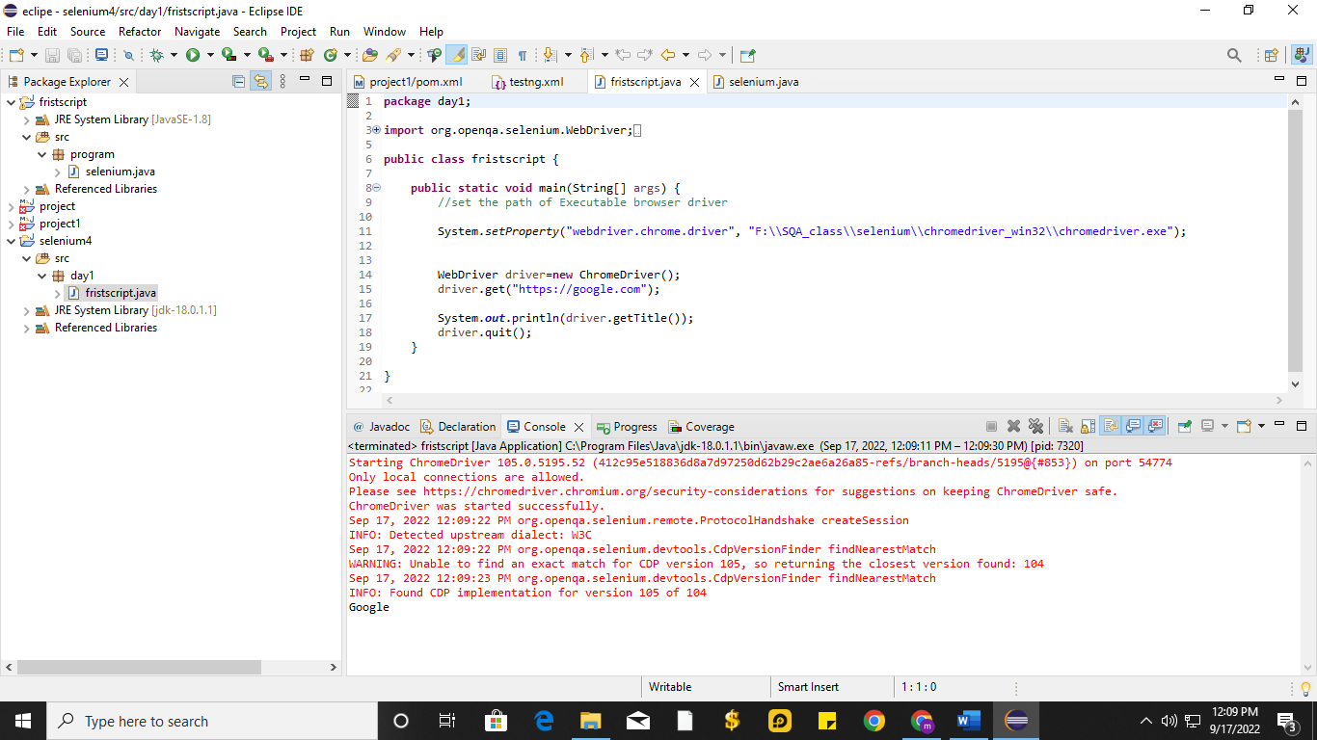

package day1;

import org.openqa.selenium.WebDriver;

import org.openqa.selenium.chrome.ChromeDriver;

public class fristscript {

public static void main(String[] args) {

//set the path of Executable browser driver

System.setProperty("webdriver.chrome.driver", "F:\\SQA_class\\selenium\\chromedriver_win32\\chromedriver.exe");

WebDriver driver=new ChromeDriver();

driver.get("https://google.com");

System.out.println(driver.getTitle());

driver.quit();

}

}

#2nd project

Linkedin site login with valid username and password automation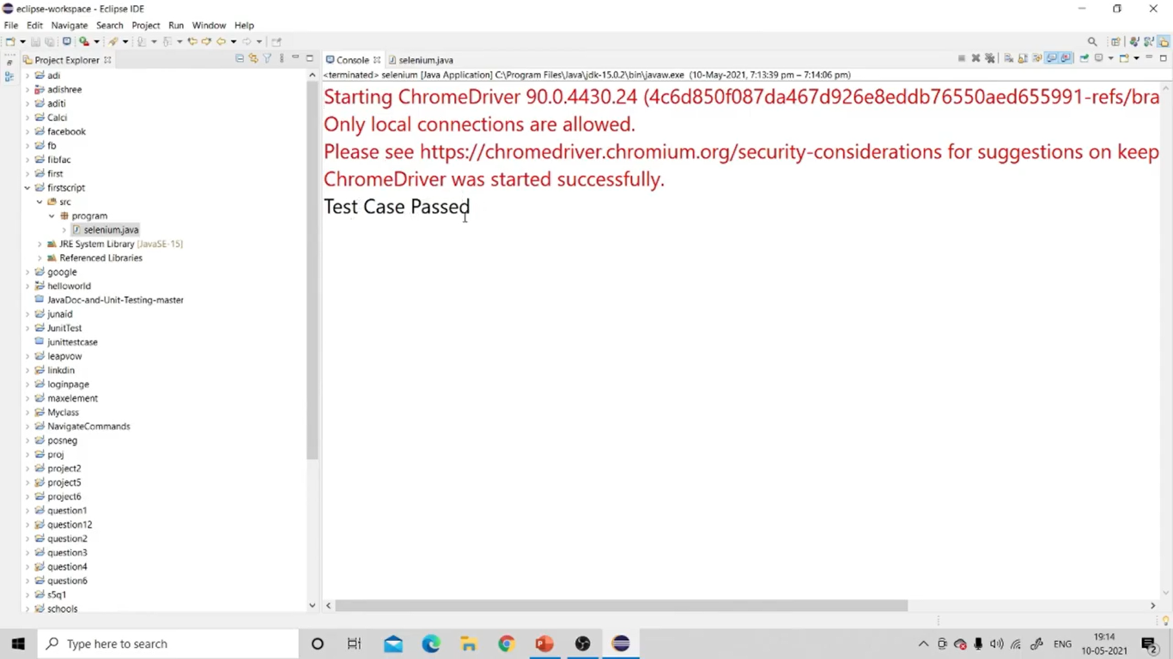

package program;

import org.openqa.selenium.By;

import org.openqa.selenium.WebDriver;

import org.openqa.selenium.chrome.ChromeDriver;

public class selenium {

public static void main(String[] args) {

System.setProperty("webdriver.chrome.driver", "F:\\SQA_class\\selenium\\chromedriver_win32\\chromedriver.exe");

WebDriver d=new ChromeDriver();

d.get("https://www.linkedin.com");

d.findElement(By.id("session_key")).sendKeys("abc@gmail.com");

d.findElement(By.id("session_password")).sendKeys("abce@999");

d.findElement(By.xpath("//*[@id=\"main-content\"]/section[1]/div/div/form/button")).click();

String u=d.getCurrentUrl();

if(u.equals("sign-in-form__submit-button"))

{

System.out.println("Test Case passed");

}

else {

System.out.println("tast case is failed");

}

d.close();

d.quit();

}

#3rd project

amazon website automation 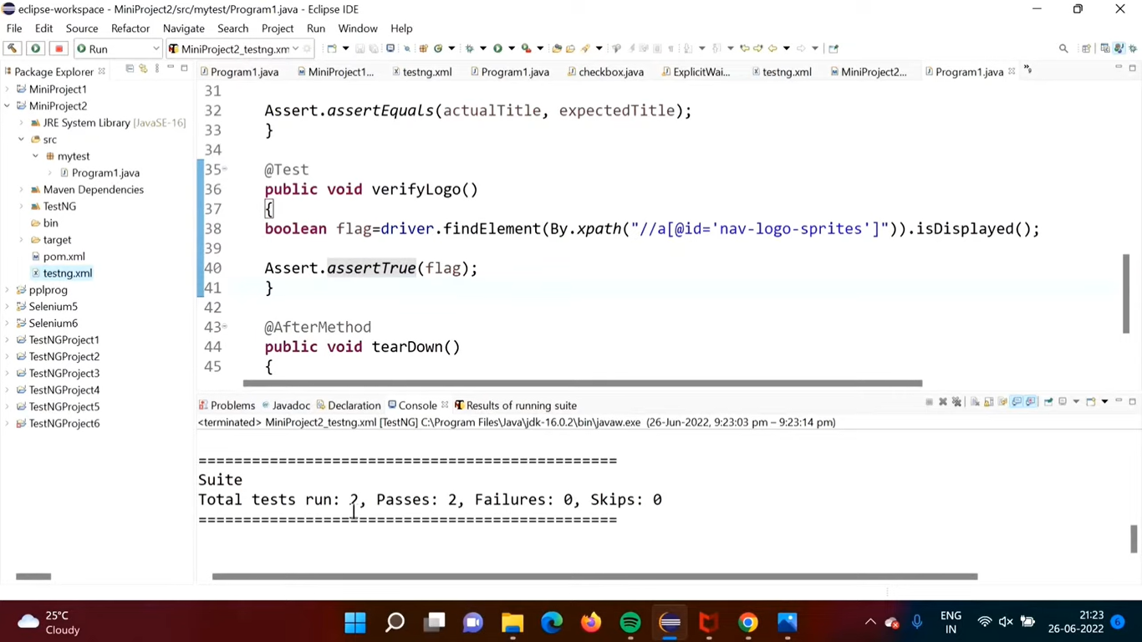

Program Code (Program1.java) :

package mytest;

import java.time.Duration;

import org.openqa.selenium.By;

import org.openqa.selenium.WebDriver;

import org.openqa.selenium.chrome.ChromeDriver;

import org.testng.Assert;

import org.testng.annotations.AfterMethod;

import org.testng.annotations.BeforeMethod;

import org.testng.annotations.Test;

public class Program1 {

WebDriver driver;

@BeforeMethod

public void setUp()

{

System.setProperty("webdriver.chrome.driver", "C:\\selenium\\chromedriver_win32\\chromedriver.exe");

driver=new ChromeDriver();

driver.get("https://amazon.in");

driver.manage().window().maximize();

driver.manage().timeouts().implicitlyWait(Duration.ofSeconds(5));

}

@Test

public void verifyTitle()

{

String actualTitle=driver.getTitle();

String expectedTitle="Online Shopping site in India: Shop Online for Mobiles, Books, Watches, Shoes and More - Amazon.in";

Assert.assertEquals(actualTitle, expectedTitle);

}

@Test

public void verifyLogo()

{

boolean flag=driver.findElement(By.xpath("//a[@id='nav-logo-sprites']")).isDisplayed();

Assert.assertTrue(flag);

}

@AfterMethod

public void tearDown()

{

driver.quit();

}

}

Program Code (pom.xml) :

<project xmlns="http://maven.apache.org/POM/4.0.0" xmlns:xsi="http://www.w3.org/2001/XMLSchema-instance" xsi:schemaLocation="http://maven.apache.org/POM/4.0.0 https://maven.apache.org/xsd/maven-4.0.0.xsd">

<modelVersion>4.0.0</modelVersion>

<groupId>MiniProject2</groupId>

<artifactId>MiniProject2</artifactId>

<version>0.0.1-SNAPSHOT</version>

<dependencies>

<!-- https://mvnrepository.com/artifact/org.seleniumhq.selenium/selenium-java -->

<dependency>

<groupId>org.seleniumhq.selenium</groupId>

<artifactId>selenium-java</artifactId>

<version>4.3.0</version>

</dependency>

</dependencies>

<build>

<sourceDirectory>src</sourceDirectory>

<plugins>

<plugin>

<artifactId>maven-compiler-plugin</artifactId>

<version>3.8.1</version>

<configuration>

<release>16</release>

</configuration>

</plugin>

</plugins>

</build>

</project>

Program Code (testng.xml) :

<?xml version="1.0" encoding="UTF-8"?>

<!DOCTYPE suite SYSTEM "https://testng.org/testng-1.0.dtd">

<suite name="Suite">

<test name="Test">

<classes>

<class name="mytest.Program1"></class>

</classes>

</test> <!-- Test -->

</suite> <!-- Suite -->